01.05
Configuration management
Process Design & AMOS Configuration Document
Purpose
This Process Design document is provided to Key-Users to record their key decisions regarding the AMOS Process design and the required AMOS configuration.
It is updated throughout the Project Definition Phase and used as the baseline for the Final Acceptance prior to Go-Live
Revision
Author, Name | Date | Notes
SWISS-AS | 30 APR 2024 | draft
PRADEEP PATHIRANA | 24.May 2024 | 1. version
PRADEEP PATHIRANA | 12.December 2024 | 2. version

Table of Contents
1. Process Overview & Objectives 3
2. References 3
3. Definitions & Glossary 3
4. Process Tasks 4
5. Process Dependencies 4
6. Process Flow 5
7. Process Design Questions 6
8. Data (Source) Mapping 7
9. Other Software Used 7
10. AMOS Configuration 8
a. Basic Data 8
b. Parameters 8
c. Workflows 9
d. Scheduled Tasks 10
e. API’s & Interfaces 11
11. UAT Guidance 11
12. Annex – Additional Info 11
• “Configuration Management Creation, migration and best practices” Document 11

Process Overview & Objectives

Process General Description:
Configuration Management can be defined as the process of identifying the items in the system, controlling the change of these items throughout their lifecycle, recording and reporting the status of items and change requests, and verifying the completeness and correctness of items.

Main Process Objective (Outputs & Outcomes) :
The main aim of Configuration Management is to keep aircraft airworthy by tracking the "as booked" configuration (installed Component) for a specific aircraft type (or aircraft tail sign) compared to its "allowed" configuration. An allowed PN may have a status (Allowed / Preferred / Mandatory).
The first baseline for the "allowed" configuration is always the delivery document supplied by the OEM. This OEM list references the minimum components that should be tracked but can be amended with any other components that are usually not supplied along with the delivery documents (e.g., BFE equipment like seats, loose equipment, etc.). The engineering department can decide and add in the allowed Rotables that they consider critical (e.g., high-value components, components often robbed during line maintenance activities).
Furthermore, for the e-enabled aircraft, the configuration management validates the "as flying" configuration (Configuration extracted directly from the aircraft) to its "allowed" and "as booked" configurations.
Currently, AMOS supports As-Flying reports for the following AC types: - A350, A380, B787
AMOS supports managing software at the assembly level, enabling the receiving, installing, and removing of software within the assembly. (AMOS 24.12 onwards)

References

EASA – Regulation 1321/2014 - M.A.301 Continuing airworthiness tasks

Definitions & Glossary

Key-Words | Explanation
LocID - Location identifier | Function Position for Software/Hardware FIN, SLID / ERD
LRU | Line Replacement Unit
LLP | Life Limited Part
AIR | Aircraft Inspection Report (Airbus)
ARL | Aircraft Readiness Log (Boeing)
FP - Function Position | Function Position for Software/Hardware FIN, SLID / ERD
BFE | Buyer Furnished Equipment
SFE | Seller Furnished Equipment

Process Tasks

Business Process Task / Actions / Activities :
- Create new / adjust existing Aircraft configuration – To allow use of the module to its full potential, at least one Aircraft Configuration per type should be present
- Create new /adjust existing assembly configuration – to enable configuration control of assemblies, but also serves as a pre-condition for enabling Receiving/Booking of entire assemblies (instead of using Component Trees method)
- Assign configuration (A/C & Assembly)
- Create new Media(Rotable) and Add/ Remove the Software in Media
- Perform Software booking and tracking.
- Control of configurations – Creating reports to check compliance

Process Dependencies

- 01.02 Part Definition
- 01.04 SB & AD Assessment
- 02.01 Aircraft Phase-In
- 08.02 Performing Maintenance
- 10.03 Major Assemblies

Process Flow
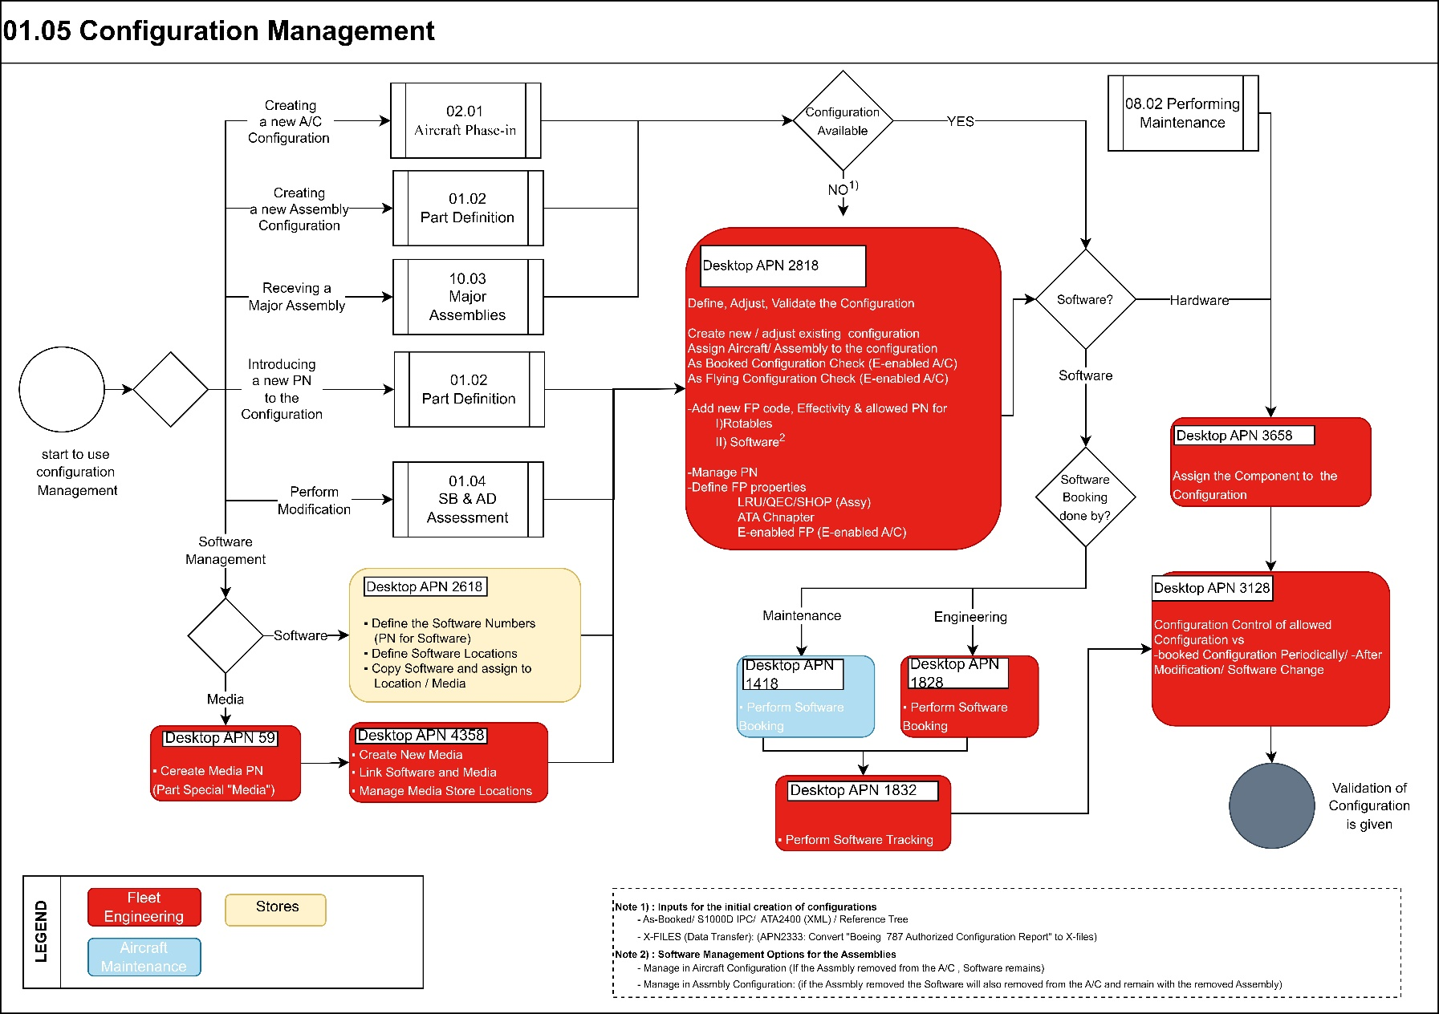

Process Design Questions

# | Question | Answer
1 | Who is responsible to maintain the A/C configuration?  It is the same Department that controls the Assembly Configuration?  It is the same Department that controls the Software Configuration?
2 | Who will be responsible to audit the Configuration?  Technical Records department, Engineering…?
4 | Which department is responsible for performing the “Tree-Receiving” actions in AMOS? (Engine Assy., LLP S/N recording)
5 | Who should be responsible for forwarding modification changes (related to configuration changes, e.g., software updates, etc.) to the configuration management team?  Which medium should be used (e.g. Technical Assistance Query APN 869)?
6 | Is your company having a harmonized fleet per aircraft type or aircraft types equipped with different assemblies from different vendors (e.g. A330 is only equipped with RR-engines or you have as well A330 with PW-engines?)
7 | Is your fleet e-enabled? Would as-flying configuration be validated in AMOS?
8 | How Do you Manage Software for the Assemblies (in A/C level or Assembly level)

Data (Source) Mapping

Data Sources | Description | Volume / Manual / Automatic / Static / Dynamic

Other Software Used

Other Softwares | Used by: | Description

AMOS Configuration

Add comments about the AMOS Configuration

Basic Data

Basic Data Table | Notes
NIL | Some basic data tables were applicable to previous process flows using APN 27, not needed for new customers adopting CM

Parameters

Parameter Code | Parameter Name | Notes
1222 | LABELBOOKING POSITION FIELD | Stipulate, if the Position Field in the Label Booking is mandatory.
1675 | USE "CONTROLLED FUNCTIONAL POSITIONS" / "NEW CONFIGURATION MANAGEMENT" IN "COMPONENT TREE LABEL BOOKING" | String = Y
1681 | Modifications PRE / POST Status | Allows complex Rule setup to catch the correct PRE/POST status of a modification  INT=1 (default)  defaults:  PRE: -,O,B,G,J,A / POST: C,F,T,V,H
1723 | Activate Tree Receiving with Config Management | String = Y  With the parameter activated, the new way of doing "Tree Receiving" using "Config Management" is available in "Component Inspection & Records".
1732 | Use configurations in Parts Consumption Forecast | String = Y  PCF will allocate parts or orders according to alternates and configurations defined in Configuration Management
1871 | Configuration Definition parameters setup | This parameter can only be setup in Material Configuration APN 3125
1893 | Custom FP Generator | Allows fully customizable Functional Position name generation (in APN 3125) for automatic FP creation from As-booked config
1911 | Configuration scope setup | This parameter can only be setup in Material Configuration APN 3125
1963 | Multiple template allowed for ToolBox | This parameter define if it`s possible for user to have multiple template applicable to their tool box.
1976 | Activate new Software Definition UI | Parameter used to activate new Software Definition UI.  It displays additional information in a new tab in the Software Management module.

Workflows

Workflow Number | Workflow Name | Notes
86 |  | This workflow is triggered when a rotable component is installed via the AMOS program "Rotables Label Booking".  Available wildcards:  - conf_mgmt_inst_assembly_status_not_okay - Triggered if there is at least one FP checked as wrong in the Tree (Missing but LRU excluded)  - conf_mgmt_inst_assembly_has_missing_lru_items – Triggered if there is at least one FP checked as Missing (but LRU) at the time of the booking.
183 | Rotables Label State Before Booking | This workflow is triggered right before a "Rotables Label Booking" is executed. It gives AMOS Customers the possibility to act depending on the state of the Label before the Booking.  Available wildcards:  - conf_mgmt_inst_assembly_status_not_okay  Triggered if there is at least one FP checked as wrong in the Tree (Missing but LRU excluded)  - conf_mgmt_inst_partnumber_is_not_specified_for_func_pos  Triggered if the ON part is not allowed for the Functional Position.  - conf_mgmt_other_partnumber_found_as_preferred_for_func_po  Triggered if the ON part is allowed for the Functional Position but not as “Preferred”.  - conf_mgmt_other_partnumber_found_as_mandatory_for_func_pos  Triggered if the ON part is allowed for the Functional Position  but is not “Mandatory”.  - conf_mgmt_inst_pn_is_specified_for_fp_but_outside_date_validity_boundary  Triggered if the ON part is allowed for the Functional Position, but is outside of the date validity defined in the PN List.
369 | Rescue Kit Functional Position Revision | To be used if Rescue Kit function for e-enabled Aircrafts is used to inform watch list owner that a change on a Rescue Kit related Location had been performed in APN:1927
391 | After inspection | Following wildcards can be used:  - is_tree_receiving_config_status_ok:  The checker runs when finishing the Inspection of an Assembly. This wildcard is set to “True” if the checker detects no discrepancy.  - rotable_tree_mode  For the Rotable inspected, returns if there is an Allowed Configuration applicable, or a Ref Tree applicable, or both, or none.  - tree_receiving_mode  Returns the Tree Receiving method used (Ref Tree based, or Config Based)

Scheduled Tasks

Scheduled Task Reference | Frequency | Notes
ConfigurationCheckerTask | Every day, overnight | Make active
SRTConfigurationChangeTask | Not applicable – client-specific (SR Technics) | Not relevant to Configuration Management  Explained here to avoid other clients’ confusion
SRTConfigurationChangeLightTask | as above | as above
SoftwareManagementMigrationTask | On-Demand | This task will migrate software from the Location & Copy framework to the Software Media framework.

API’s & Interfaces

Reference | Direction | Trigger | Frequency
EXPORT GE CONFIGURATION
EXPORT SRT CONFIGURATION CHANGE |  |  | N/A (SR Technics only)
EXPORT SRT CONFIGURATION CHANGE LIGHT |  |  | N/A (SR Technics only)
TRANSFER AMOS ALLOWED CONFIGURATION
TRANSFER ATA AIRCRAFT ALLOWABLE CONFIGURATION
TRANSFER BOEING EDMS
TRANSFER AIRBUS AS FLYING CONFIGURATION |  |  | N/A
TRANSFER AIRBUS AS FLYING CONFIGURATION OPS |  |  | N/A
TRANSFER BOEING AS FLYING CONFIGURATION | IN |  | TBC (if viable)

UAT Guidance

UAT No | Proposed User Acceptance Test scenario
01.05.1 | Creation of a new assembly configuration – Aircraft
01.05.2 | Creation of a new assembly configuration - Part Assembly
01.05.3 | Update of an existing assembly configuration
01.05.4 | Receiving process of a simple assembly
01.05.5 | Receiving process of a Complex assembly and installation on an Aircraft

Annex – Additional Info

“Configuration Management Creation, migration and best practices” Document

